# Problem 3 - Elite Workout

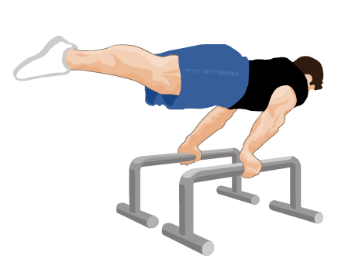

*Stay Hard! Push your limits and break through barriers. Every rep, every set, and every drop of sweat brings you one step closer to your goals. Embrace the struggle, honour the process, and transform your potential into power. Your strength knows no bounds – keep striving, progress, and never settle!*

As a callisthenics athlete, you need to develop a workout **training** **plan**. Each exercise should include the targeted **muscle** **group**, the **name** of the exercise, and its **difficulty** **level**.

On the following lines, until the command "**Stay Hard!**" you will receive commands to complete the perfect workout routine:

* "**Exercise: {exercise_name}#{muscle_group}#{difficulty_level}**":
  + If the exercise is **not in** the training plan, **add** it as you **save** the muscle **group**, the exercise **name**, and the difficulty **level**.
  + Otherwise, print on the console:
    - "**Exercise {exercise_name} is already in the training plan**"
* "**Weight Vest: {exercise_name}#{weight}**":
  + For the given exercise, you will use a weight vest to increase the intensity. The difficulty level **increases** by **weight** value.
  + If the exercise is **not** **in** the training plan, print on the console:
    - "**Exercise {exercise_name} is not in the training plan**"
* "**Progress: {muscle_group}**":
  + As you get stronger, exercises will become easier to perform. Monitor your progress and **remove** all exercises related to the given **group** from your training plan.
  + If the **muscle** **group** is **not** **in** the training plan, print on the console:
    - "**Group {muscle_group} does not exist in the training plan**"

After processing all commands, the program should:

* Print the whole **training** **plan** on the console:
  + "**Training Plan:**"
  + **" * {exercise_name1} hit {muscle_group1} and have difficulty level {difficulty_level1}**

**…**

* + **\* {exercise_namen} hit {muscle_groupn} and have difficulty level {difficulty_leveln}"**
* Otherwise, if there are **not** any exercises in the plan, print on the console:
  + **"Training plan is under development!"**

## Input / Constraints

* Input continues until "**Stay Hard!**" is received.
* All lines of code will be correctly formatted as described.

## Examples

|  |
| --- |
| **Input** |
| Exercise: pull-ups#back#32  Exercise: push-ups#chest#9  Exercise: pull-overs#core#47  Exercise: dips#shoulders#40  Stay Hard! |
| **Output** |
| Training Plan:  * pull-ups hit back and have difficulty level 32  * push-ups hit chest and have difficulty level 9  * pull-overs hit core and have difficulty level 47  * dips hit shoulders and have difficulty level 40 |
| **Input** |
| Exercise: plank#core#23  Exercise: leg raises#core#25  Exercise: burpees#full body#52  Progress: core  Weight Vest: burpees#40  Progress: chest  Stay Hard! |
| **Output** |
| Group chest does not exist in the training plan  Training Plan:  * burpees hit full body and have difficulty level 92 |

## JS Examples

|  |
| --- |
| **Input** |
| (["Exercise: pull-ups#back#32",  "Exercise: push-ups#chest#9",  "Exercise: pull-overs#core#47",  "Exercise: dips#shoulders#40",  "Stay Hard!"]) |
| **Output** |
| Training Plan:  * pull-ups hit back and have difficulty level 32  * push-ups hit chest and have difficulty level 9  * pull-overs hit core and have difficulty level 47  * dips hit shoulders and have difficulty level 40 |
| **Input** |
| (["Exercise: plank#core#23",  "Exercise: leg raises#core#25",  "Exercise: burpees#full body#52",  "Progress: core",  "Weight Vest: burpees#40",  "Progress: chest",  "Stay Hard!"]) |
| **Output** |
| Group chest does not exist in the training plan  Training Plan:  * burpees hit full body and have difficulty level 92 |